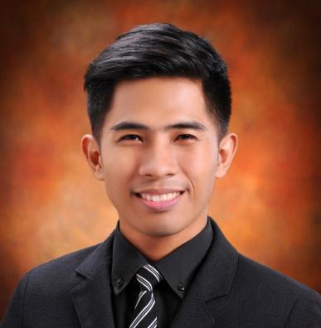

**Fred J. Urot**

Purok Calachuchi

Lo-ok, Lapu-Lapu City

Mobile Number: +639086351142

Home Number: (032) 239-4306

E-mail: urot.fred.fred@gmail.com

**Objectives:**

* To enhance my educational and professional skills in a stable and dynamic workplace.

**Education:**

Graduate October 2017

University of San Carlos – Technological Center

BS Information and Communication Technology

**Experiences**

Live2Sell Group of Companies

* Technical Support - OJT May 2016

Dynata

* Survey Programmer June 2018

Accenture

* Associate Software Engineer June 2019

Justlearn

* .NET Developer Jan 2021

**Skills**

* Intermediate knowledge in MSSQL, MySQL, PHP, C++, Java C#, ASP.NET, .NET Core, JavaScript languages.
* Basic knowledge in Flutter, ReactJS, Python languages.
* Basic knowledge in SQL Server Integration Services and SQL Server Reporting Services.
* Basic knowledge in Azure Build and Release.
* Intermediate knowledge in Visual Studio Code, Microsoft Visual Studio.
* Intermediate knowledge in troubleshooting.
* Basic knowledge in Network Management.

**Achievements**

* Dean's Lister First Semester 2016

**References:**

Mr. Archival Sebial, MSCS

Faculty, Department of Computer Science

Capstone Project Adviser

University of San Carlos

09274857788

Mr. Juvinal Alvarado

Chief Technology Officer

Justlearn

092992933651

act.jalvarado@gmail.com

Mr. Livi Israel Dajime

Senior Software Engineer

Accenture

09055028554

Livi.israel.a.dajime@accenture.com